Agency: _______________________________
State Building ID or Lease Number: City: _____________

Prepared by: Approved by: Date Submitted:

1. AGENCY ORGANIZATIONAL STRUCTURE
Please attach an organizational chart depicting the hierarchy of the agency from the executive down to individual positions. Below is an example of a standard format:

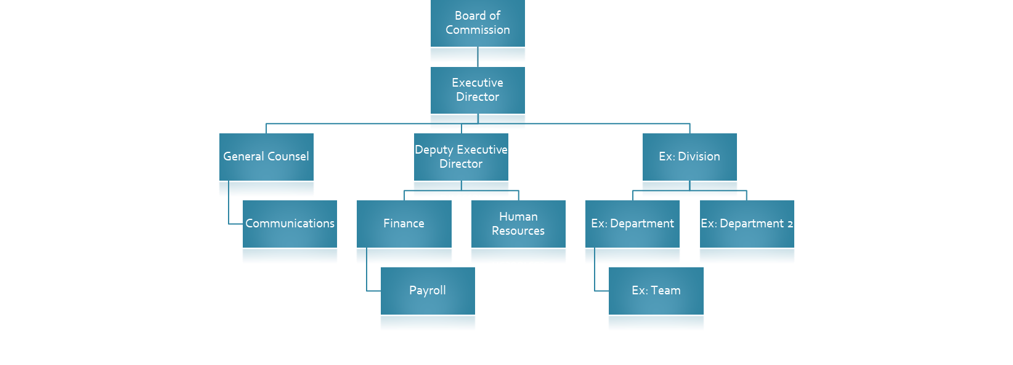
2. FTE & GROWTH DETAILS
Division Name:
Please provide the current number of FTEs and Future Growth by detailing the position groupings to the smallest level (e.g., team > department > division). Add rows as necessary.
Title  Format: Department-Team (e.g., Finance-Payroll) | Current  FTE  Count | Future  FTE  Count | Future  Growth  Timeframe

3. ADJACENCY REQUIREMENTS
Please indicate any adjacency priorities of each grouping to another using one of the following Priority Codes:
A = Essential; B = Important, not critical; C = Helpful; D = To be avoided
Groupings can be identified at Division level for high level needs and Team level for more specific adjacency needs.
Add Rows as necessary.

Name | To | Name | Priority Code

4. EVALUATION OF EXISTING SPACE & POST PANDEMIC STRATEGY
Note any space economies and current efficiencies you hope to maintain and any space related problems that you hope to resolve or avoid. Please provide an overview of what your expectations of a post pandemic workplace will look like for your team.

5. GEO-LOCATION REQUIREMENTS
Provide any geo-location requirements that your agency has mandated (e.g., City, ZIP Code)
Agency will be required to provide justification, if within a limited boundary

6. SECURITY
Note any special requirements that your space must address in terms of restricted access.

7. SPECIAL ENVIRONMENTAL CONTROLS
Note any unique cooling or heating requirements (e.g., IT Rooms, After-Hours Work, Humidity Control) that would require special consideration. Please provide as much detail as possible when identifying these needs.

8. VISITORS
Note the average daily number of visitors, peak number of visitors, and peak time periods for each group within a division. Add rows as necessary.
Name  Format: Department-Team | Average # of Visitors | Peak  # of Visitors | Peak Time Periods

9. CONFERENCE ROOM REQUIREMENTS
Note any meeting of more than 4 individuals and identify the average size, length, frequency, and scheduling prioritization of each meeting. Identified meetings should be organized by host, use the accompanying codes for meeting sizes and scheduling priority. Add rows as necessary.

Size Code | Scheduling Code
1 = 4 to 6 people | A = Highest priority
2 = 7 to 10 people | B = Regularly scheduled
3 = 11 to 15 people | C = Non-routine, but may be scheduled
4 = 16 to 30 people | D = May be held as space is available
5 = 31 to 50 people
Other = Indicate # of people

Host  Format: Department-Team | Meeting Title/Function | Size Code | Meeting  Length | Meeting  Frequency | Scheduling Code

10. POSITION INVENTORY
Note the position titles organized by group, provide # of positions in the quantity and any special notes specific to that position. Add rows as necessary.

Group Name: Indicate the Department and Team that the FTE Position Title is assigned to
Position Title: Indicate the formal title of the position
QTY: Indicate the number of positions of the same title assigned to the group
Special Notes: Please provide any details that would be pertinent in planning for the Position(s)

 | Group Name  Format: Department-Team | Position Title | QTY | Special Notes
1
2
3
4
5
6
7
8
9
10
11
12
13
14
15
16
17
18
19
20
21
22
23
24
25
26
27
28
29
30
31
32
33
34

11. SUPPORT SPACE INVENTORY
Note the support spaces needed to facilitate your agency’s functions. Add rows as necessary.

Room Type: Please refer to Section 11a for a list of room types and their descriptions to assist in identifying any spaces necessary.
Room Function: Use this space to provide further detail of what the space will be used for (e.g., Room Type = Storage could be further clarified as Room Function: Gun Closet.)
Special Notes: Please provide any details that would be pertinent in planning for the requested Room Type (e.g., Adjacencies, Equipment Needs, Furniture, etc.)

 | ROOM TYPE | ROOM FUNCTION | QTY | Special Notes
1
2
3
4
5
6
7
8
9
10
11
12
13
14
15
16
17
18
19
20
21
22
23
24
25
26
27
28
29
30
31
32
33

11a. Room Type Titles and Descriptions

Room | Desc
AUDITORIUM | Stages, audience seating areas, and platforms must be named auditoriums. Auditoriums have structurally changed floors and/or ceilings. These spaces generally have above-standard air conditioning and are larger than 400 square feet. Upper parts of auditorium are also named AUDITORIUM (in the same way as a set of stairs is named STAIR on every level).
BREAK | Room or area used by employees during break times. This may include a service unit and can also contain miscellaneous storage, localized mail stop facilities, and other miscellaneous office amenities.
COMPUTER | Room used for computers, servers, and their related electronic functions and activities.
CONFERENCE | Any office room used primarily as a conference room by a single occupant. There are certain qualifications a room must meet to receive the Space Type CFT (Conference/Training). A room that is named and used as a conference room does not necessarily mean it has a Space Type CFT.
COPY | Room used exclusively or primarily for photocopy machines. Room can also contain files, storage, supplies, and other typical office items. Predominate use of room must be to photocopy.
CUST. | Custodial Room that contains a one or more standard sink or mop sink and is used by custodial services for their related activities. A janitorial storage room would have the room name STORAGE and Space Type CST, not room name CUST.
EQUIP. RM. | Equipment Room. Audio/Visual equipment rooms associated with conference rooms, courtrooms, and auditoriums. Room used to house radio equipment and/or conduct associated activities. Not to be used as building support mechanical rooms. Rooms housing machinery for courtroom lifts are named MECH.
EVIDENCE | Room used to secure legal evidence, usually near a courtroom.
FILE | Room used primarily for hardcopy files. Room can also contain storage, supplies, and other typical office items. Predominant use of room must be to house hardcopy files.
HEARING | Hearing Room used by courts as the location to which evidence is taken for the purpose of determining an issue of fact.
HUB RM. | Hub Room. Space used as a computer hub room. Contains server and/or electronic equipment racks.
HUB/TELE. | Hub/Telephone. Room is a combined computer hub room and telephone equipment room.
INTERVIEW | Room in which interviews are conducted.
LAB. | Laboratory. Space equipped for experimental study in a science, or space for testing and analysis.
LACTATION RM. | Lactation Room. A private room for nursing mothers. Space must be private, clean and include a shelf/table and a seat. Often times they include other provisions, such as electrical outlets, refrigerator, etc. It is assigned as Joint Use when available to all nursing mothers in the building.
LIBRARY | Space in which literary, musical, artistic, or reference materials (as books, manuscripts, recordings, or films) are kept for use but not for sale.
LOADING DOCK | Architectural structure designed for efficient loading and unloading of trucks.
MAIL RM. | Mail Room. Space in which activities related to handling incoming and outgoing mail occur. If one occupant requests and uses the mailroom, it must be assigned to the occupant. It is assigned as Joint Use space when the mail room is used by all occupants.
PRINT RM. | Print Room. Room in which document printing or plotting occurs.
RECEPTION | Room or area where receptionist is located.
STORAGE | Room used primarily for storage. Room can also contain files, supplies, and other typical office items. Predominant use of room must be storage. This name includes cold storage rooms such as walk-in freezers or coolers used for food service or by laboratories. A trash or recyclables room used to store Building Common trash, recyclables or dumpsters are also named storage.
SWITCH RM. | Switch Room. Contains electrical switch gear and equipment.
TELE. | Telephone. Room or closet containing telephone equipment and/or panels.
TELLER | Room where a teller conducts business. A teller station within an open office setting, such as in a credit union, is usually not assigned as a separate space. A room within the building line such as a room for a drive-up window teller is assigned the room name TELLER.
TRAINING | Room used to conduct training. Note the difference between a classroom and a training room is the training room has no special build-out.
VEST. | Vestibule. A small passage, hall, or room between a door or room and another room, corridor, or lobby.
WAITING | Area for patron/clientele traffic. Can include seating. Also can include drivers’ waiting rooms at a LPOE.
WORK RM. | Work Room. An open room or area used by many people performing various work-related tasks. Different from OPEN OFFICE because there are no office-related workstations.

